Mouse-Maze Problem

Problem : A mouse finding the paths in a Maze, from starting point ‘s’ to destination ‘d’.

Maze =

Keep track of each path, and steps taken (Up, Down, Right, Left) during journey.

0 Specifies the path is closed

1 Specifies the path is open

Algorithm :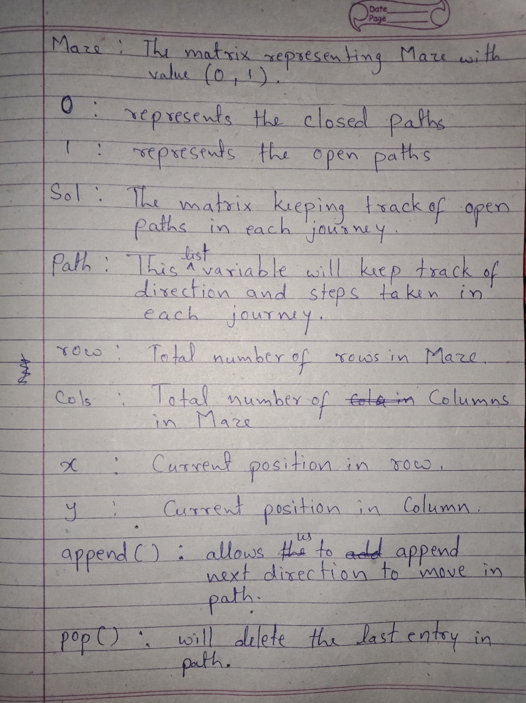

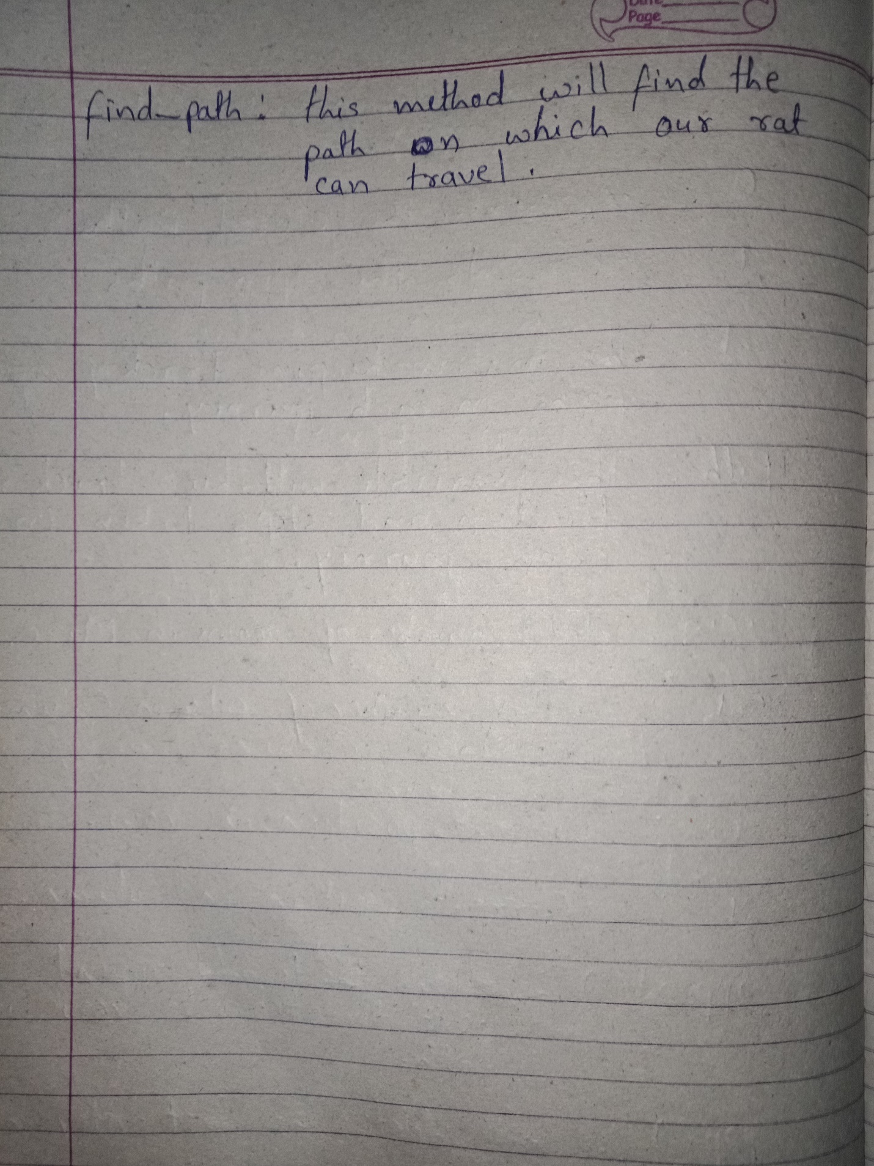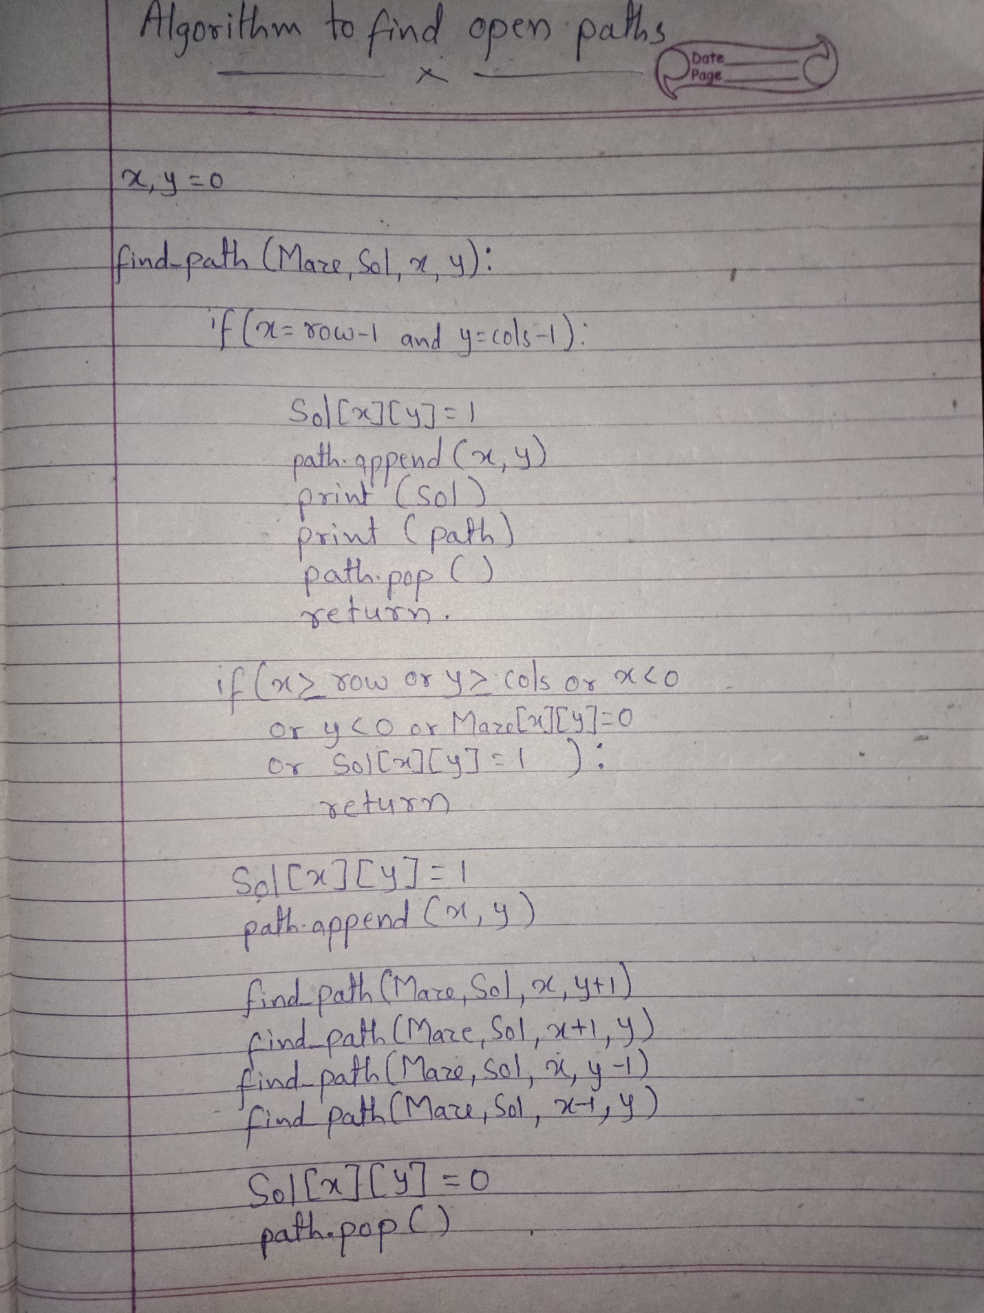

Running Time Analysis :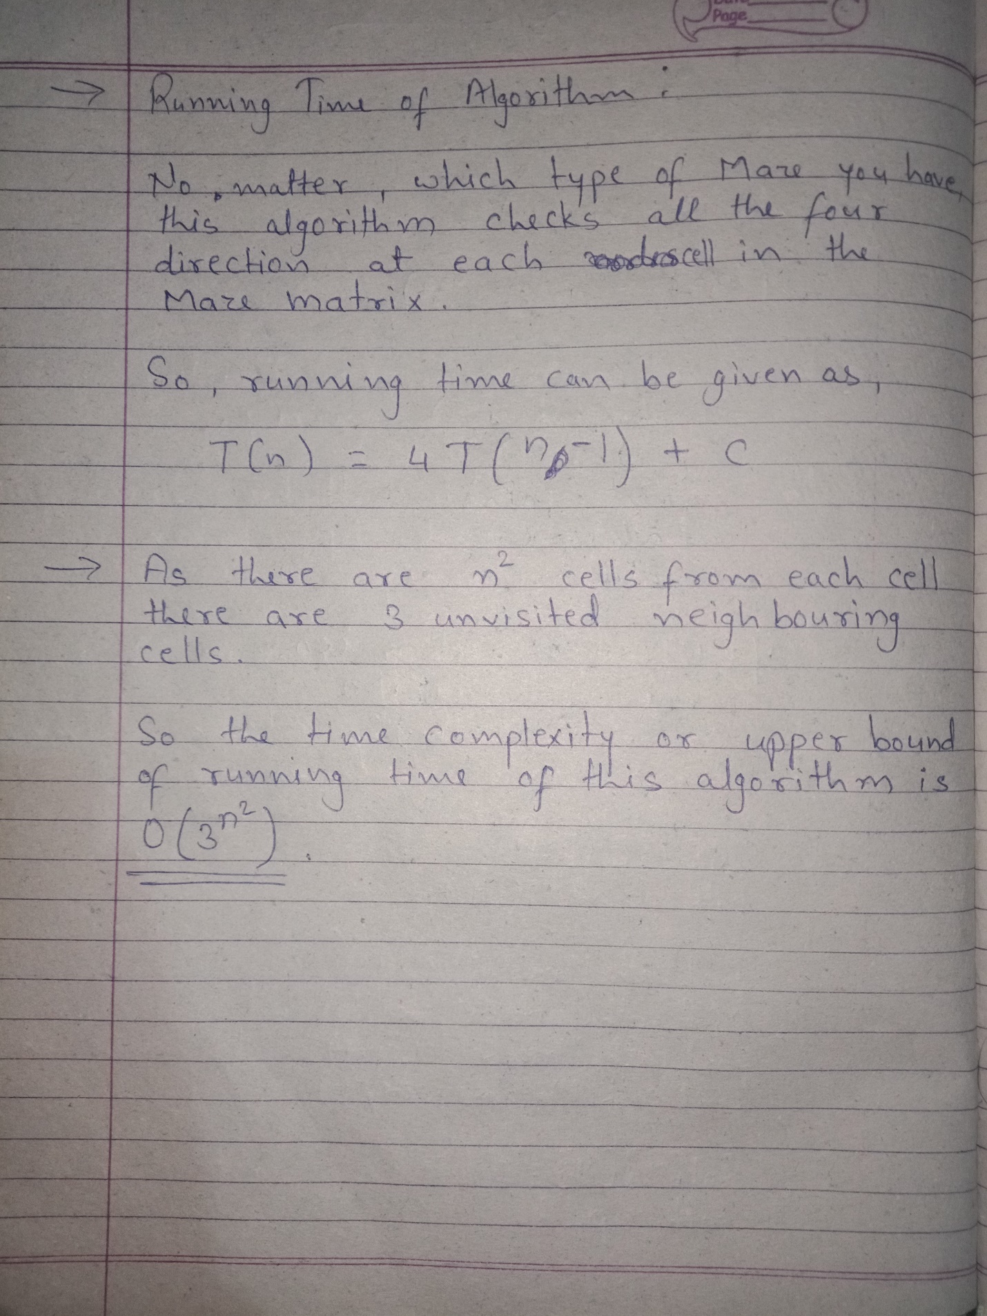

Program:

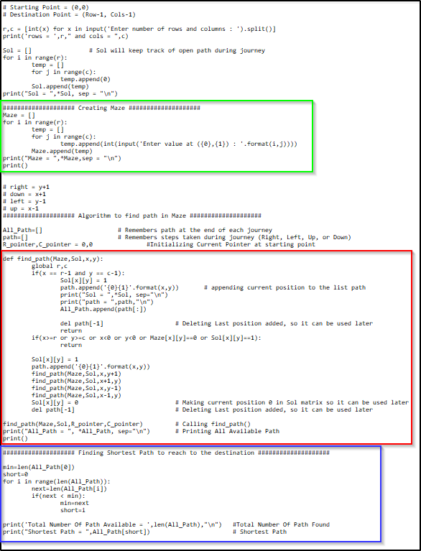

Output:

